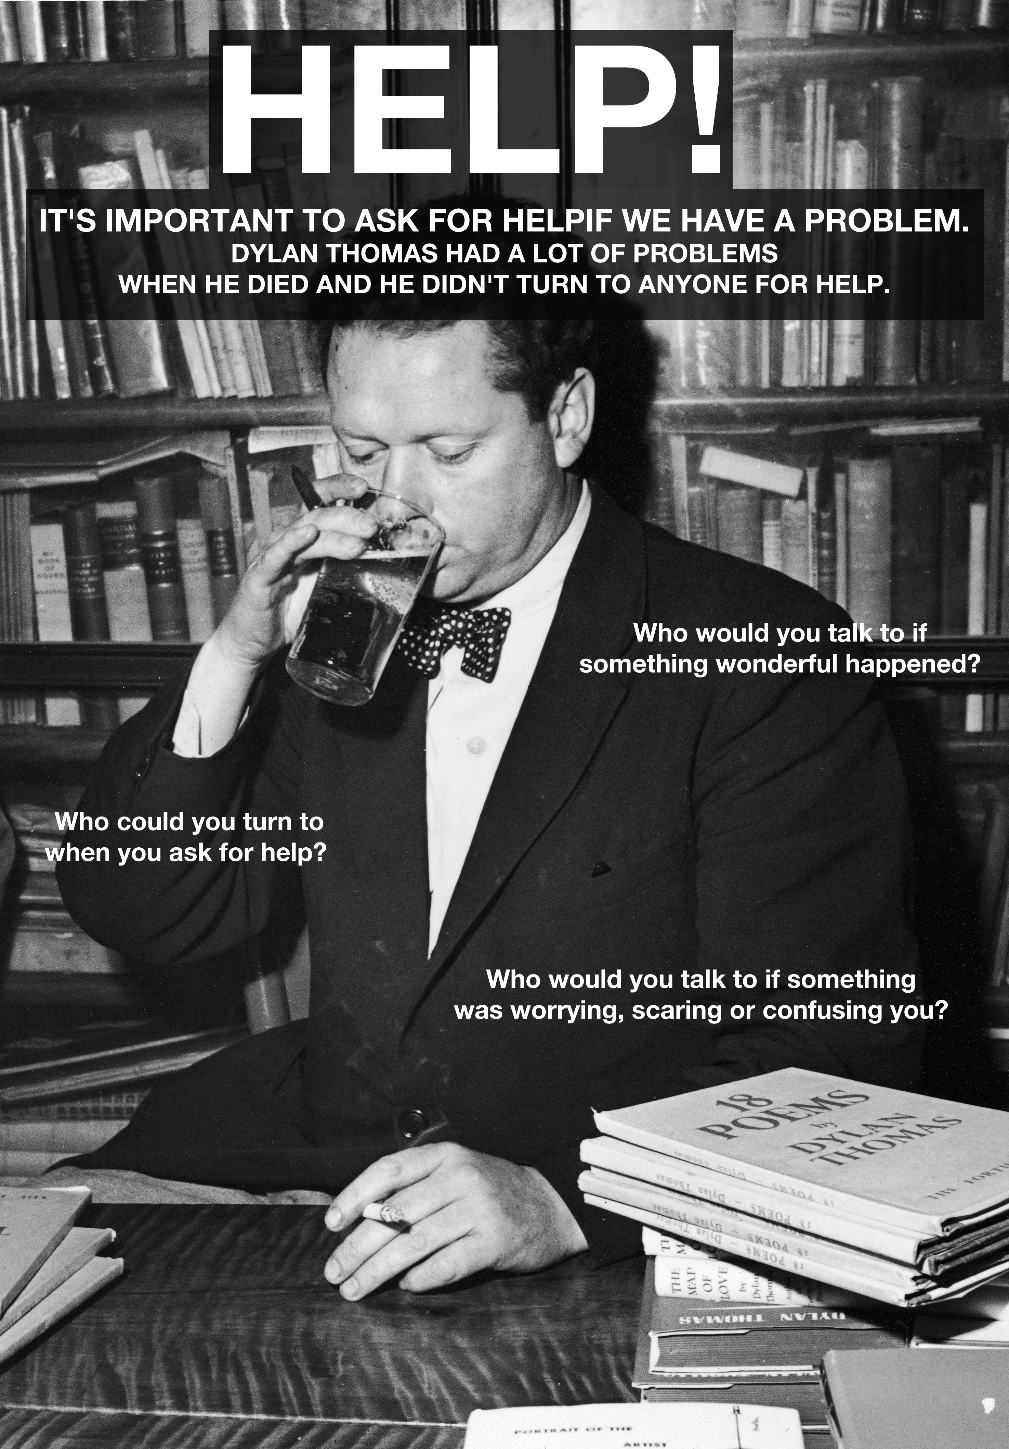

Teaching ideas
- As a class, view the clip of Hannah Ellis talking about Dylan Thomas not asking for help www.rockanrollpoet.co.uk > KS2 > Video
- Discuss with the learners who they can turn to for help in various situations
- Ask the learners to write who are the four most helpful people to them and how do they help them. Resources for this can be found on the Children's Society website at http://www.mylife4schools.org.uk/teachers/runaways
- Discuss what drugs are, explaining that some drugs are good for us, such as medicines, and some drugs are bad for us.
- Discuss the dangers of smoking and drinking.
- Role play: create a short play where a learner says no to a peer who is trying to persuade him or her to smoke.

